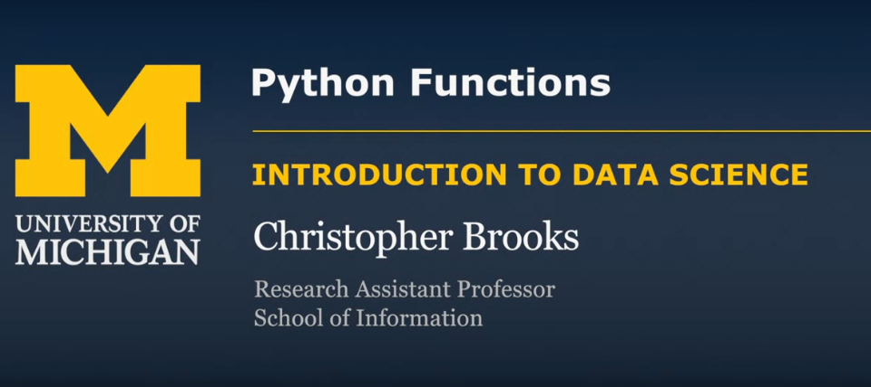

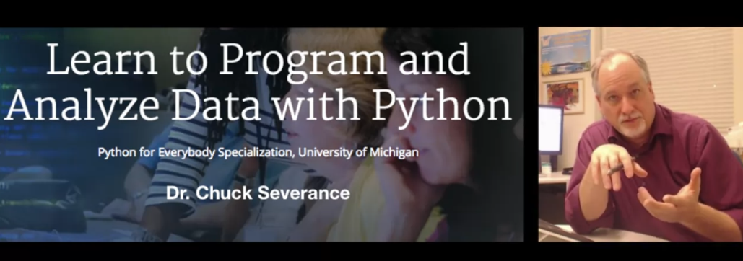

Python is a high level language means it is optimized by people of ML

Interpretable language

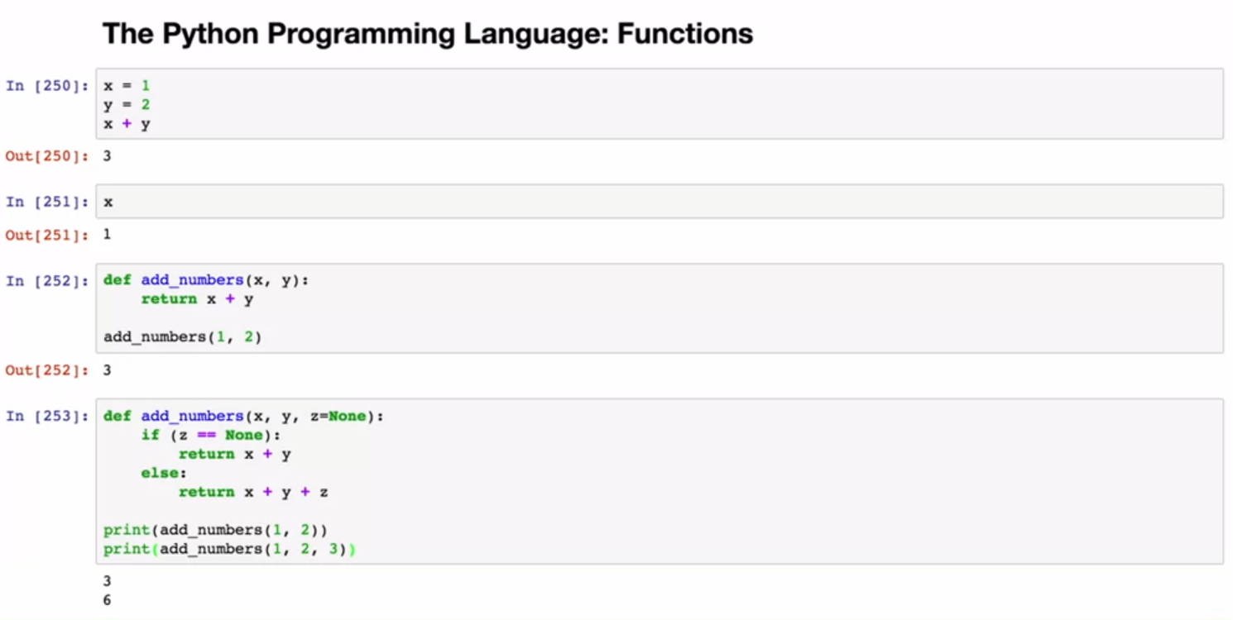

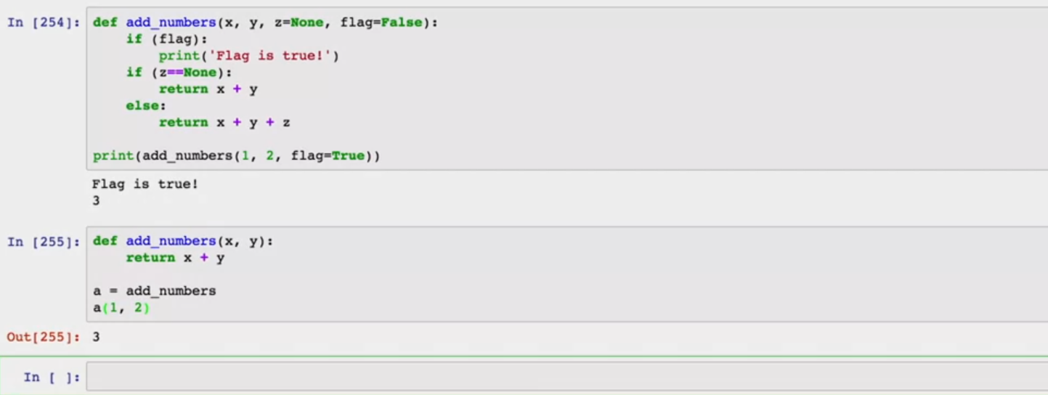

A flag in Python acts as a signal to the program to determine whether or not the program as a whole or a specific section of the program should run.

In other words, you can set the flag to True and the program will run continuously until any type of event makes it False